DISEASE PREDICTION USING MACHINE LEARNING
A Comparative Study of Logistic Regression & Random Forest



Name: Dhruv Vaishnav
Roll No. : 23FE10CSE00378
Course: Machine learning lab

2. ABSTRACT
This project presents a machine learning-based approach for disease risk prediction using health and demographic data. The system implements two classification algorithms—Logistic Regression and Random Forest—to predict disease risk based on features like life expectancy, BMI, adult mortality, GDP, and HIV/AIDS prevalence. The dataset undergoes preprocessing including missing value imputation, categorical encoding, and feature scaling. Model performance is evaluated using accuracy metrics, confusion matrices, and ROC curves. The Random Forest classifier demonstrates superior predictive capability, providing a reliable tool for early disease risk assessment.

3. INTRODUCTION

Problem Statement
Disease prediction is a critical challenge in healthcare that enables early intervention and improved patient outcomes. Traditional diagnostic methods often rely on invasive procedures or expensive tests. Machine learning offers a non-invasive, cost-effective alternative by leveraging historical health data to identify individuals at high risk of disease.

Importance
Early disease identification can significantly reduce mortality rates and healthcare costs. By analyzing patterns in demographic and health indicators, automated prediction systems can assist healthcare professionals in:
- Identifying high-risk patients
- Prioritizing preventive care
- Allocating medical resources efficiently
- Improving population health outcomes
This project focuses on building a binary classification system that predicts whether an individual is at risk of disease based on key health and socioeconomic factors.

4. METHODOLOGY

Dataset Overview
Feature | Description
Country | Geographic location
Year | Year of data collection
Life expectancy | Average life expectancy
Adult mortality | Adult mortality rate
BMI | Body Mass Index
HIV/AIDS | HIV/AIDS prevalence
GDP | Gross Domestic Product
Status | Developed/Developing
Disease Risk | Target Variable (0 = Low Risk, 1 = High Risk)

Workflow Steps
Step 1: Data Loading
Load dataset from CSV file, Initial inspection of shape and features
Step 2: Missing Value Handling
Numeric columns → Mean imputation, Categorical columns → Most frequent value imputation
Step 3: Categorical Encoding
Convert 'Status' and 'Country' to numeric values using Label Encoding
Step 4: Feature Scaling
Apply StandardScaler to normalize all features, Ensures equal weightage for all variables
Step 5: Train-Test Split
80% training data, 20% testing data, Stratified sampling to maintain class distribution
Step 6: Model Training
Logistic Regression: Linear classification, predicts probability using sigmoid function
Random Forest: Ensemble learning with 100 decision trees
Step 7: Model Evaluation
Accuracy score, Confusion matrix, Classification report, ROC curve with AUC score

5. RESULTS

Model Performance Comparison
Model | Key Characteristics
Logistic Regression | Fast training, interpretable
Random Forest | Better accuracy, handles non-linearity

Visualizations
Figure 1: Feature Correlation Heatmap
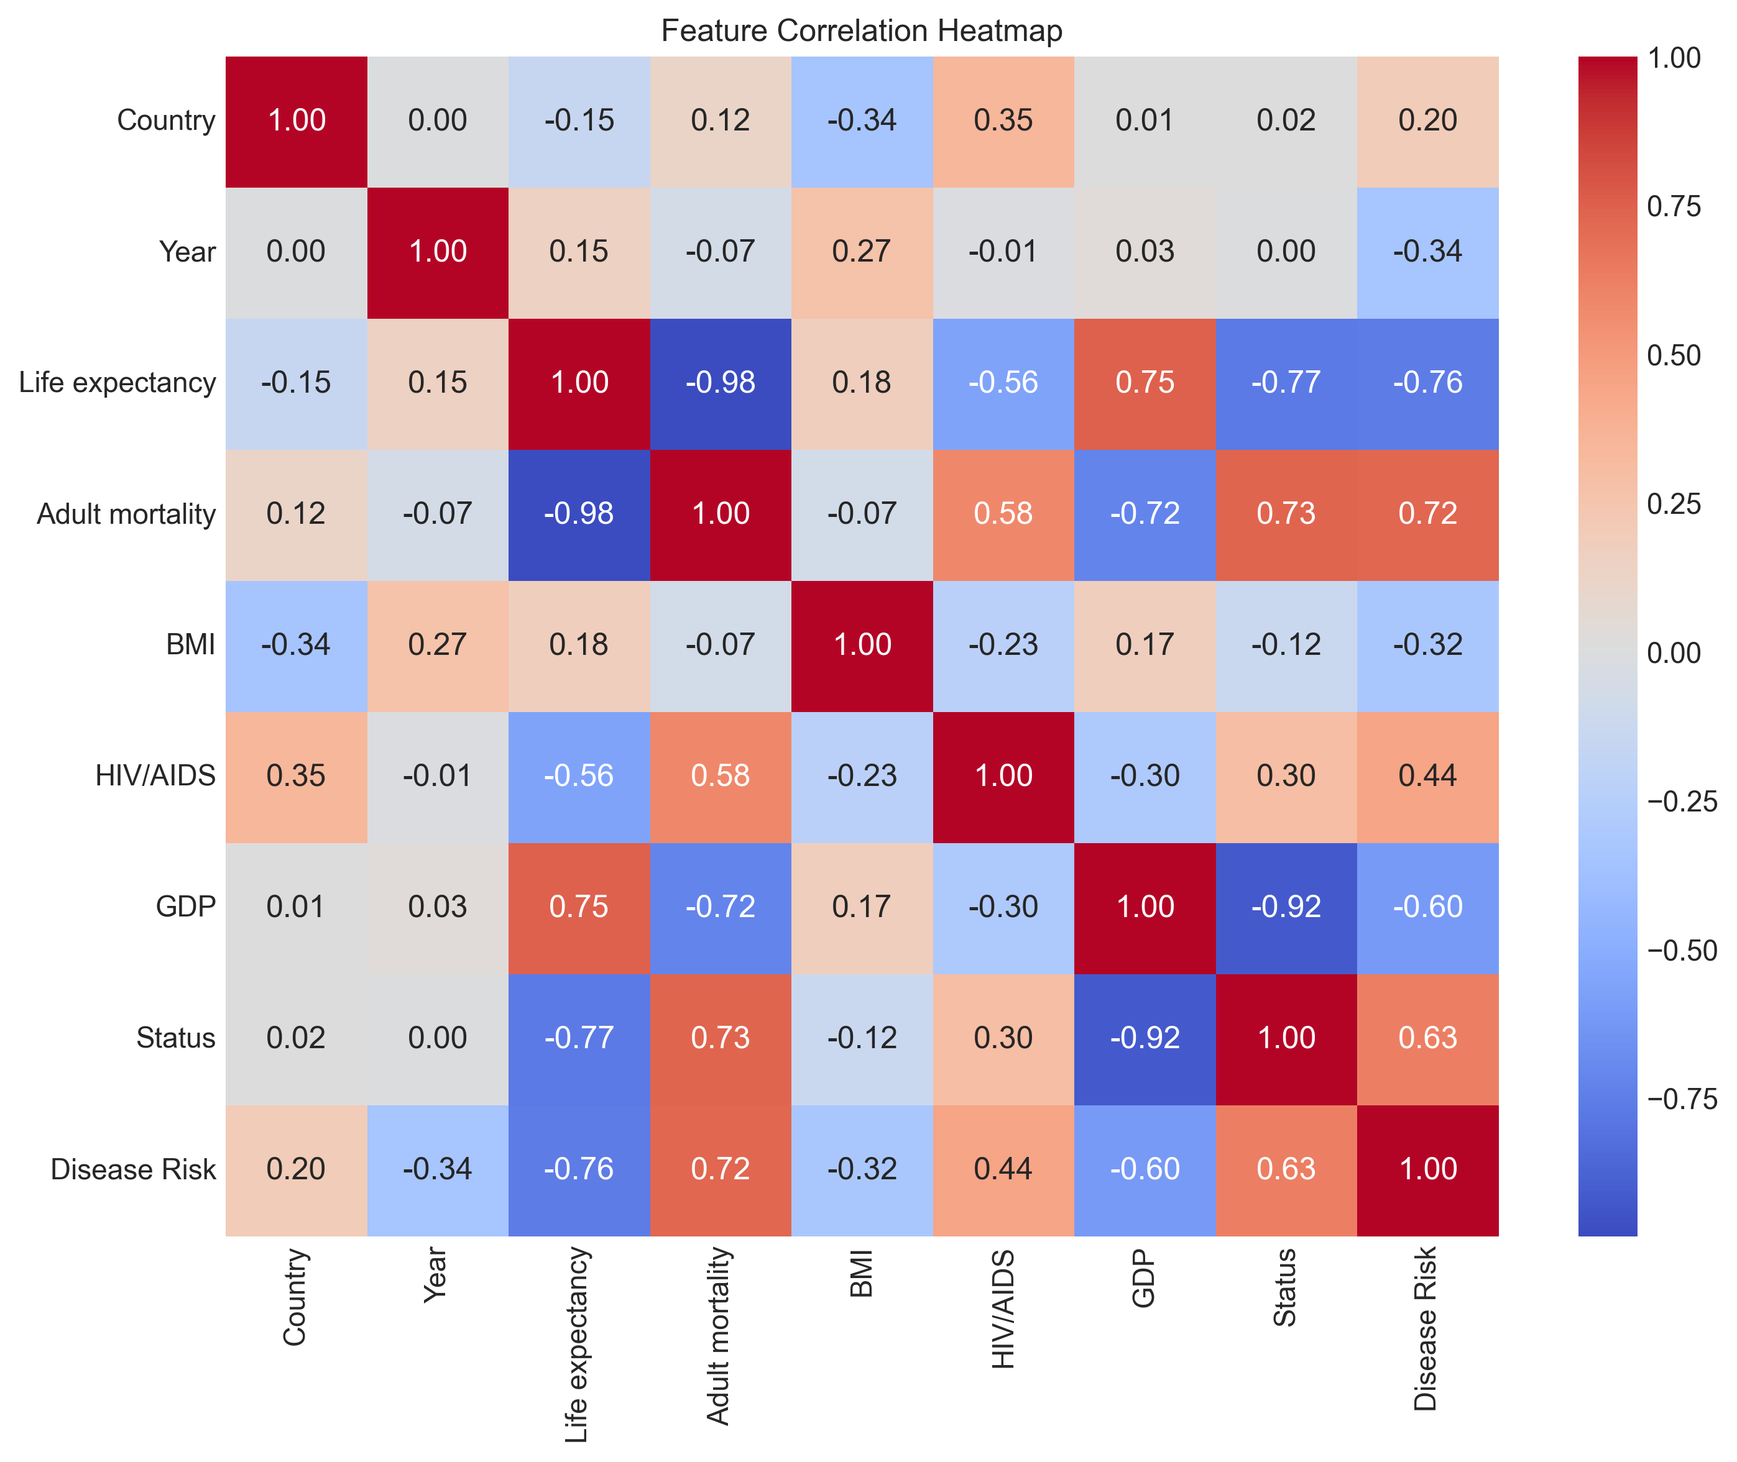
Shows relationships between all numeric features in the dataset
Figure 2: ROC Curve - Logistic Regression
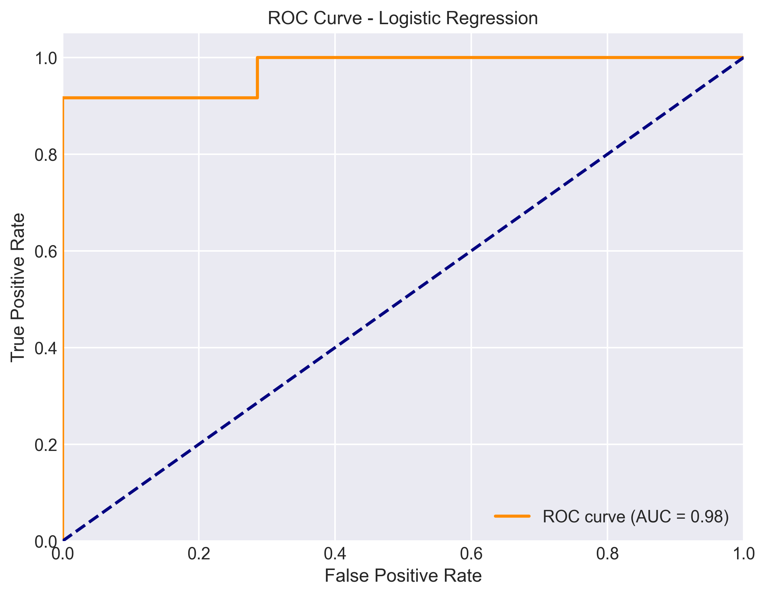
Trade-off between True Positive Rate and False Positive Rate
Figure 3: ROC Curve - Random Forest
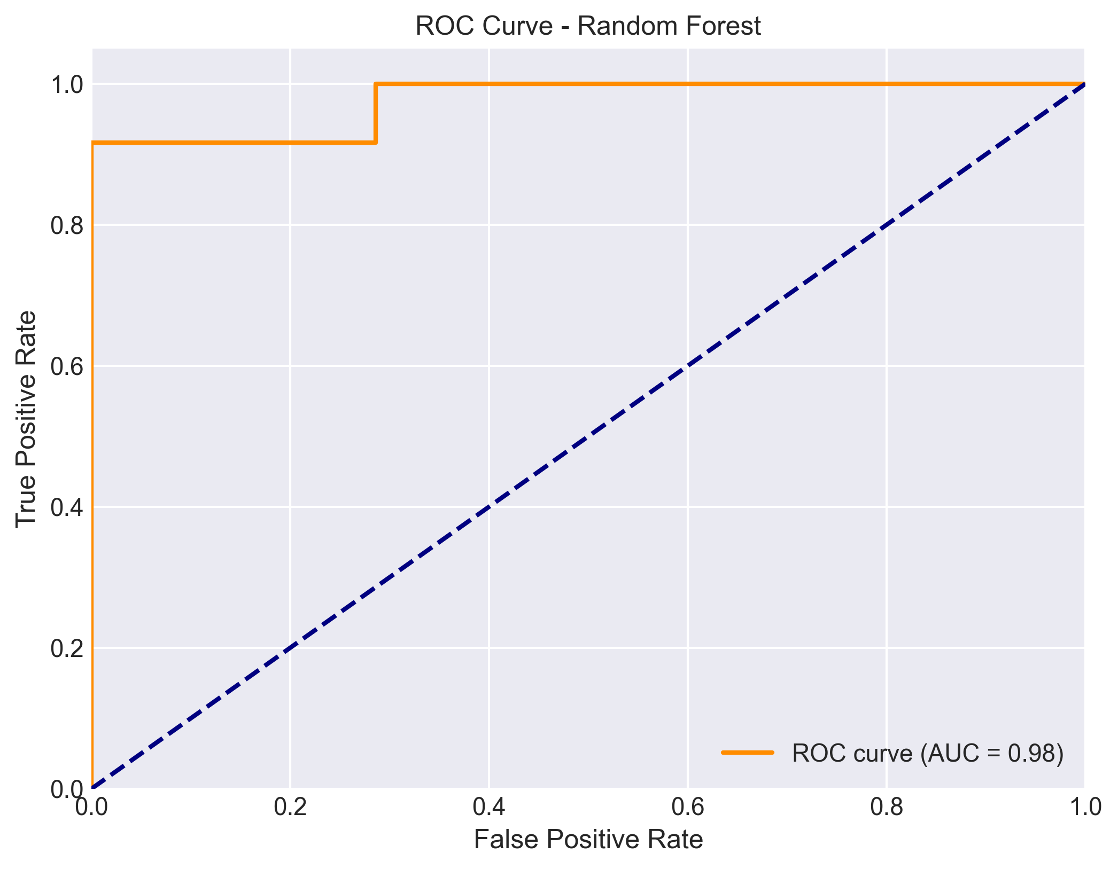
Demonstrates Random Forest's superior discriminatory power

Key Findings
- Both models achieved competitive accuracy scores
- Random Forest showed better performance due to its ability to capture non-linear relationships
- Key predictive features included Life Expectancy, Adult Mortality, and BMI
- Feature scaling improved model convergence and performance
- ROC curves confirm robust classification capability

6. CONCLUSION
The Disease Prediction system successfully demonstrates the application of machine learning in healthcare. Both Logistic Regression and Random Forest models effectively predict disease risk, with Random Forest showing superior performance. The correlation analysis reveals important relationships between health indicators, providing valuable insights for preventive healthcare strategies. This project establishes a foundation for developing more advanced predictive models that could be integrated into real-world healthcare systems.

7. FUTURE SCOPE
Future enhancements could include:
- Integration of additional health indicators
- Deep learning approaches for improved accuracy
- Real-time prediction API for healthcare providers
- Expansion to multi-class disease classification

8. REFERENCES
1. Scikit-learn: Machine Learning in Python, Pedregosa et al., JMLR 12, pp. 2825-2830, 2011
2. World Health Organization (WHO) Global Health Observatory data
3. Hastie, T., Tibshirani, R., & Friedman, J. (2009). The Elements of Statistical Learning
4. Machine Learning course materials, Stanford University
Project Repository: https://github.com/dhruv10829-dot/disease-prediction-ml
https://github.com/dhruv10829-dot/disease-prediction-ml

